1.

A Project Report On

Bank Management System
<Project Title>

Submitted in partial fulfillment of the requirement for the award of the degree

Bachelor of Computer Application BCA

Academic Year 2025 – 26

Bhavy Atkotiya | Uday faliya
92300527183 | 923005270823

Internal Guide
(Name of Internal Guide)


Rajkot-Morbi Road, At & PO : Gauridad, Rajkot 360 003. Gujarat. India.


Faculty of Computer Applications (FCA)

This is to certify that the project work entitled
Bank Management System
submitted in partial fulfillment of the requirement for the award of the degree of
Bachelor of Computer Application
BCA
of the
Marwadi University
is a result of the bonafide work carried out by

Bhavy Atkotiya :- 92300527183
Uday faliya :- 92300527083

during the academic year 2025-26

Faculty Guide |  | HOD |  | Dean

DECLARATION

I/We hereby declare that this project work entitled Bank Management
System is a record done by me.

I also declare that the matter embodied in this project is genuine work done by me and has not been submitted whether to this University or to any other University / Institute for the fulfillment of the requirement of any course of study.

Place : Rajkot
Date : 6/6/2025

CONTENTS

Chapters | Particulars | Page No.
1 | SYNOPSIS
2 | PREAMBLE  General Introduction Module description
3 | TECHNICAL DESCRIPTION  Hardware Requirement Software Requirement
4 | SYSTEM DESIGN AND DEVELOPMENT  (Only applicable diagrams)  - Flowchart  - Data Flow Diagram, Use Case Diagram,  - Sequential Diagram, Class Diagram,  - Activity Diagram  Database Design (If applicable) Screen Design & Coding
5 | CONCLUSION
6 | LEARNING DURING SIP
7 | BIBLIOGRAPHY  Online References Offline References

SYNOPSIS
Objective: Simulate ATM transactions using Java.
Summary: Java Swing GUI + JDBC backend; modules include Login, Signup, Transactions.

PREAMBLE
ATM provides self-service for banking functions. Simulates card entry, PIN validation, and financial operations.
Modules:
- Login & Signup: User authentication and registration.
- Deposit: Add funds to account.
- Withdraw & Fast Cash: Cash withdrawal with validation.
- Balance Enquiry: Check current balance.
- Mini Statement: View recent transactions.
- PIN Change: Update security PIN.

TECHNICAL DESCRIPTION
Hardware Requirement:
- Standard PC, 4GB+ RAM
Software Requirement:
- Java, NetBeans, MySQL, JDBC

SYSTEM DESIGN AND DEVELOPMENT
Flowchart:
Start → Insert Card → Validate PIN → Choose Transaction → Process → End
Data Flow Diagram:
Shows data movement: User → ATM → Database → Result back to user.
Use Case Diagram:
Customer performs: Login, Deposit, Withdraw, Balance Enquiry, PIN Change.
Sequence Diagram:
User sends request → ATM validates → Processes → Responds → Updates
Class Diagram:
Classes: Account, Transaction, ATM; Attributes: accountNo, balance, pin
Activity Diagram:
Activities flow through swimlanes: User → ATM → Bank validation
Database Design:
Tables: user_details, transaction_log
Relations: One-to-many between Account and Transactions
Screen Design & Coding:
Swing UI: JFrame, JButton, JTextField
Code in Java classes per screen; JDBC for DB access

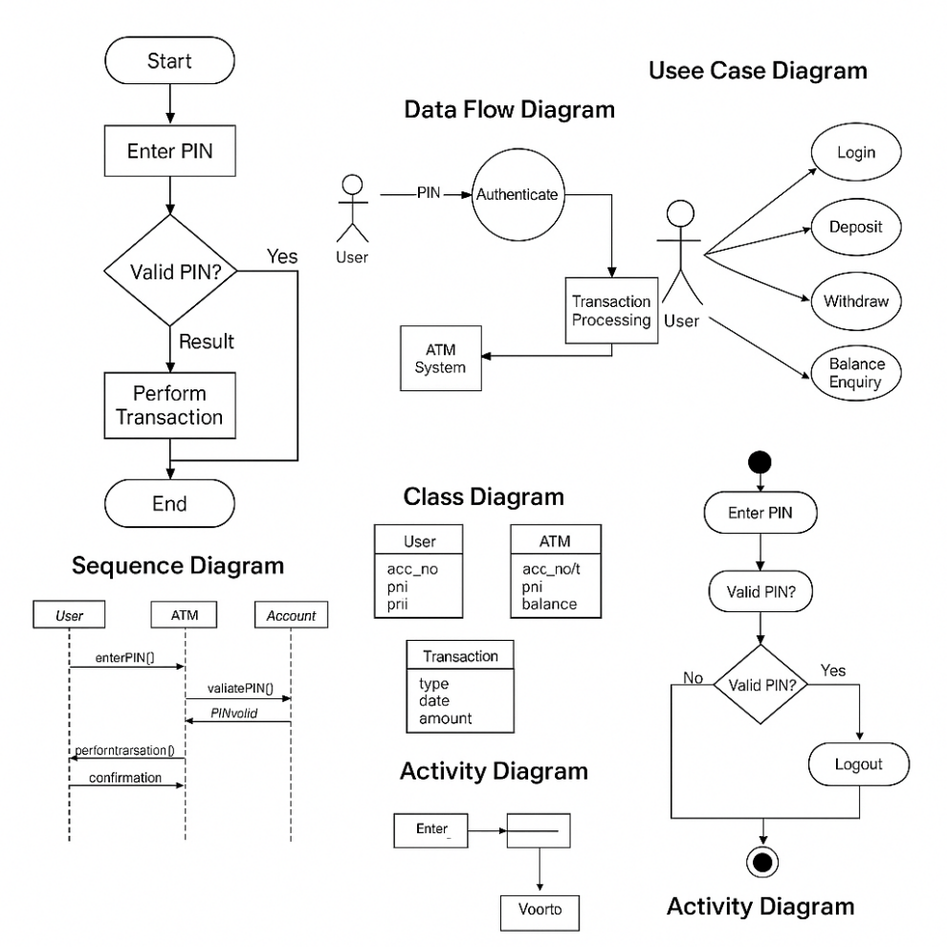

CONCLUSION
System replicates ATM workflow successfully using Java. Achieves core banking functions with proper validation.

LEARNING DURING SIP
Java GUI development, Database interaction, System Design, UML Diagrams.

BIBLIOGRAPHY
Online References:
- GeeksforGeeks
- Oracle Docs
- Kashipara
- Visual Paradigm
- Lucidchart
- GitHub
Offline References:
- (Add any textbooks or notes if applicable)

